**Providing potential students with relevant course recommendations**

Introduction

The below report will showcase the same system and approach utilised by the people and AI guidebook.

Please note that the layout of this report is based on the design process breakdown we have provided at the start of this assignment.

<https://pair.withgoogle.com/guidebook/patterns/how-do-i-get-started>

GitHub:(https://git.arts.ac.uk/21035961/Term-3-Personalisation-and-Machine-learning-Inclass-Assignments/tree/main/Term%203%20-%20InClass%20Assignments%20-%20Crysern%20Smith/Assignment%202) - Student ID - 21035961

1. Method

The problem statement addresses the issue and lack thereof of personalisation and course recommendation. We will analyse four persona/user profile needs and expectations. With the use of a personalised quiz based on the typical profile of students already on each course or who have graduated the classes, each prospective student will be asked to answer ten questions and receive 3-degree recommendations along with a video from current and graduate students on that course explaining their journey and where they currently are. The features will then be implemented and trailed in the model as the user's journey navigating the new recommendation system. A wireframe will be placed to show a solution to the problem statement.

1. Ideation

Problem statement: How might we provide potential students visiting the UAL website with more relevant/tailored course recommendations?

The entire search process is time-consuming, and when prospective students land on the UAL website, it lacks the user-friendly personalisation and recommendation that some websites have.

Based on the above, providing prospective students with more tailormade course recommendations will be the basis of the wireframe design.

3. Stakeholder mapping

|  |  |
| --- | --- |
| **Keep Satisfied**  *Prospective student* | **Manage closely**  *Web developers* |
| **Monitor**  *Current student possibly looking to further into postgraduate (i.e., based on what you have studied, I think this is a great addition)* | **Keep informed**  *Academic staff /Administration* |

1. User Profile and Need

**Persona A**: A recent High school graduate in the United Kingdom is familiar with the university but wants to get into the field of design but based on their interest, they don't know what specific design area is suitable for them.

When they begin searching the site, they see the many colleges available for design and must click into each one and then their sub-institutions to truly gauge the most suitable course for them.

**Persona B**: Is an international student looking to undertake their journey into a creative industry and has the exact needs of persona A.

**Persona C**: Is looking for either undergraduate or postgraduate, they have been working in the field for some time but are now looking to expand their education; they see changes in their related field and believe that to level up, they need to go back to education, take what they have learnt and now learn a new skill to enhance that ability.

This persona is open to all ideas but is not aware of all that UAL has to offer, i.e., the CCI.

**Persona D:** looking to progress into postgraduate but are not exactly sure what postgraduate to undertake and prefer to hear from the experiences of others in the courses they are looking into.

1. Key features and User journey
   1. User Journey

When any users enter the UAL website, they must decide what area of education they would like to focus on to do so they will consider a few key features before making any choice of college:

*Primary Features:*

• Areas of Study

• Entry Requirements

• Level of Study

*Secondary Features:*

• Desired Career Path

• Location of the college

Previous knowledge or understanding of the courses

* 1. User Journey

Figure 1 – See below for a more unambiguous indication.

1. Collaborative filtering

The model we propose to gain better recommendations will come from a pre-existing dataset. This dataset will be the many years’ worth of the previous student, either currently enrolled or who has already graduated. This data will then be collected and placed into a collaborative filtering model with the user-to-user feature. Like the quiz the prospective student will take, they will answer a quiz based on personality and many other traits.

Description of collaborative filtering:

Collaborative filtering is precisely what it means. It is a collaboration and requires many users to provide their input. It will then use a process of matching people's similar interests and making recommendations to either person within the exact geo-location, same likes and attractions, and previously watched content.

This model can work perfectly when matching the right student to the right course, which can create better class participation. (*5: Content-based filtering vs Collaborative filtering (Source... | Download Scientific Diagram*, no date; *Limitations of Collaborative Recommender Systems | by Dawn Graham | Towards Data Science*, no date)

1. Use case review and proposed prototype:

Step 1: Student goes onto UAL

**Step 2: You use the search bar and type in something generic, i.e., art**

**Step 3: You are presented with all the art-based courses, but they are not in order; they have not asked you what year or level of study you are looking for, so you will have to scroll through all the courses about art.**

The proposed prototype will be based on the user's persona and the previous case of course recommendations that UAL offers.

Proposed prototype:

**Step 1: The Student enters the UAL website and clicks on the programme quiz option:**

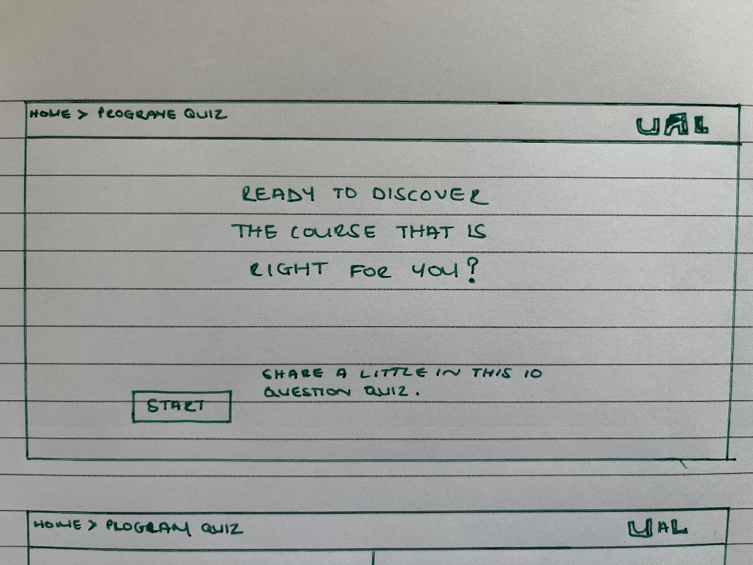

**Step 2: They then answer all ten questions**

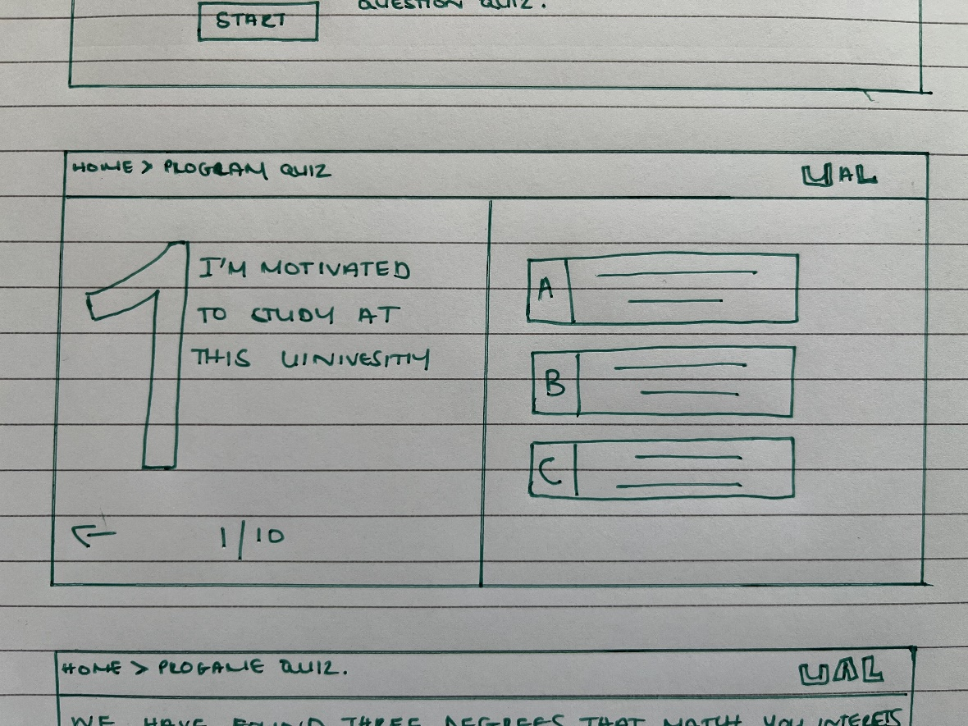

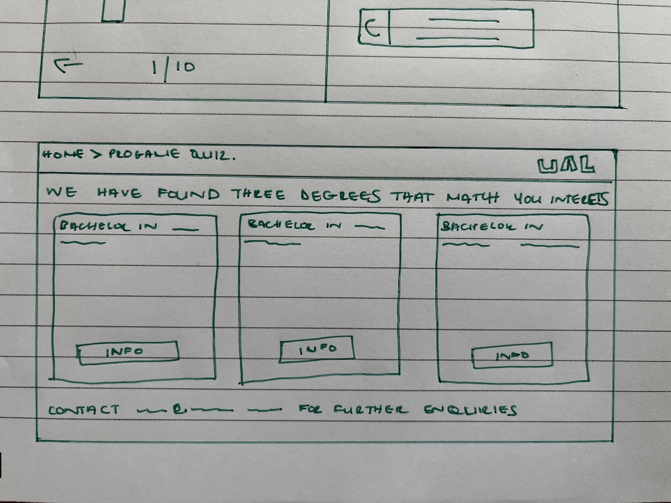**Step 3: They have completed the quiz, and based on either undergraduate or postgraduate quiz options, they are presented with the top three degrees they can enrol**.

**Step 4: When they have clicked on the course from the top three options, it goes into further explanation and provides videos from students and a live chat powered by volunteer graduates and current students.**

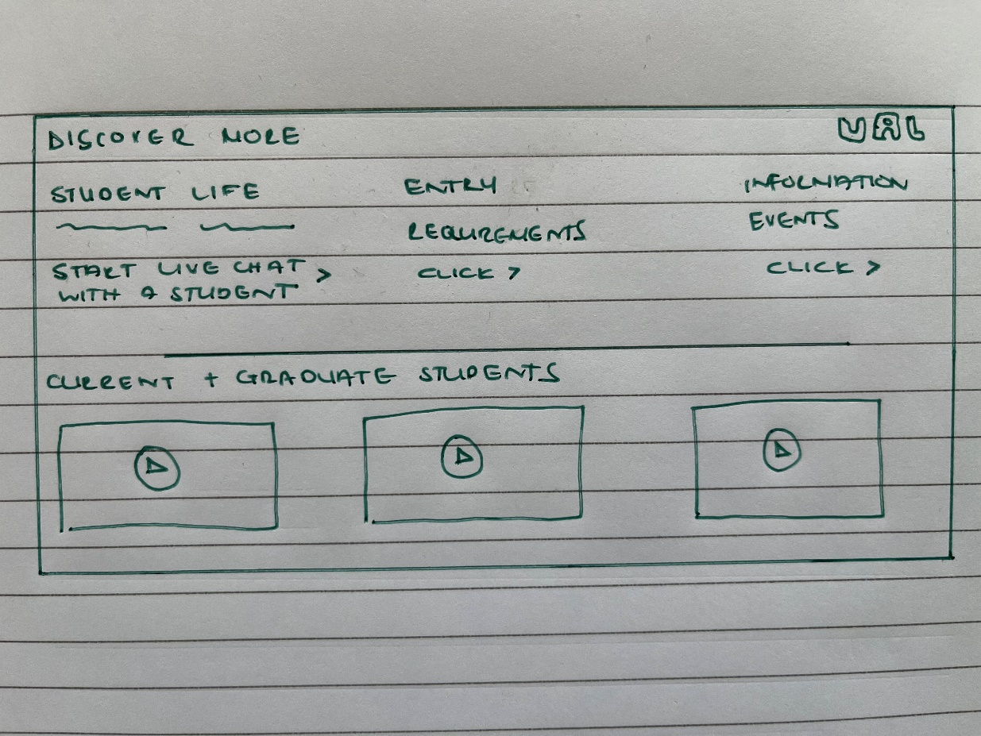

Further exploration:

On a personal experience level, to find the course I am currently on, I read reviews. Used sites such as the master portal where an online comparison between the same master's programme is made, and people provided their insights into the course.

This is a helpful tool, much like a restaurant review; I found this a beneficial tool.

And future exploration into the field of course recommendation could be an online forum and course comparison.

References:

*5: Content-based filtering vs Collaborative filtering (Source... | Download Scientific Diagram* (no date). Available at: https://www.researchgate.net/figure/Content-based-filtering-vs-Collaborative-filtering-Source_fig5_323726564 (Accessed: June 21, 2022).

*Limitations of Collaborative Recommender Systems | by Dawn Graham | Towards Data Science* (no date). Available at: https://towardsdatascience.com/limitations-of-collaborative-recommender-systems-9801036941b3 (Accessed: June 21, 2022).